Lesson 02 Demo 02

Walkthrough of Azure Cloud Shell

Objective: To get a walkthrough of Azure Cloud Shell

Tools required: Azure Active Directory user

Prerequisites: Azure subscription and storage account along with file share

Steps to be followed:
- Sign in to the Azure portal
- Launch Cloud Shell from the Azure portal
- Navigate to your choice of Azure command-line
- Run commands based on the selected environment

Step 1: Sign in to the Azure portal

- Click on the Practice Labs option available on the left side of the Simplilearn LMS

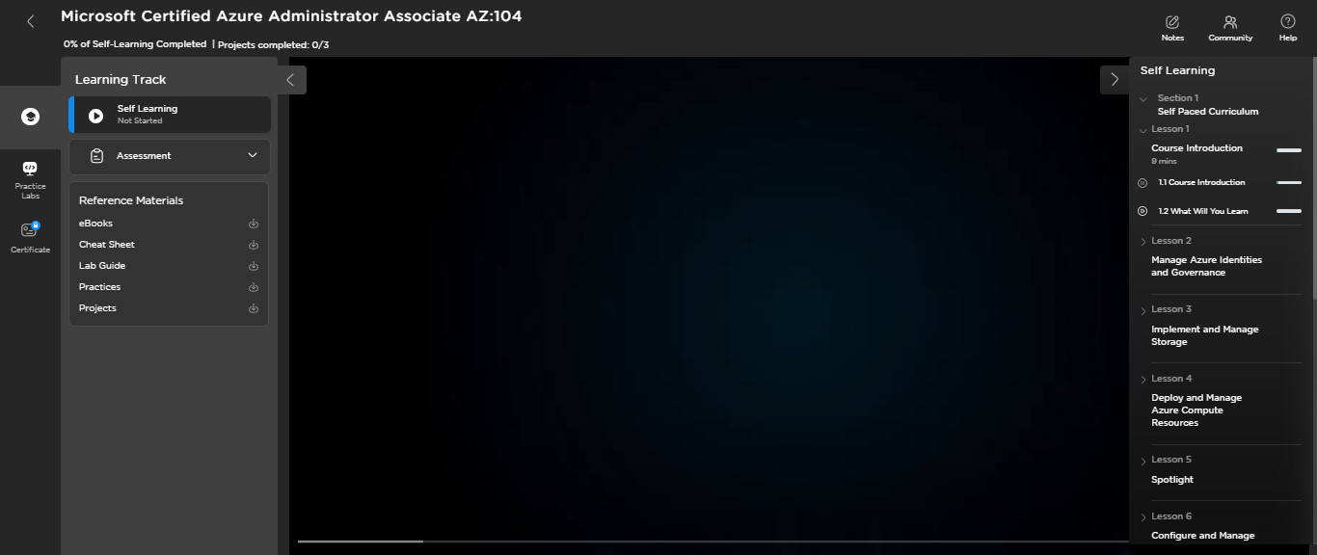

- Click on the LAUNCH LAB option in Azure Lab (AZ 104 Course)
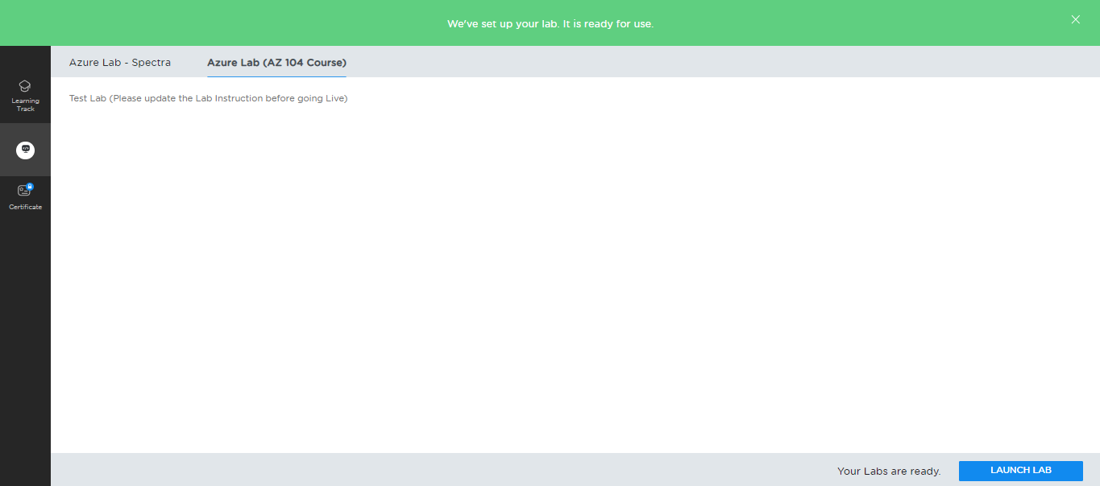

Wait for a few minutes to prepare the lab environment:

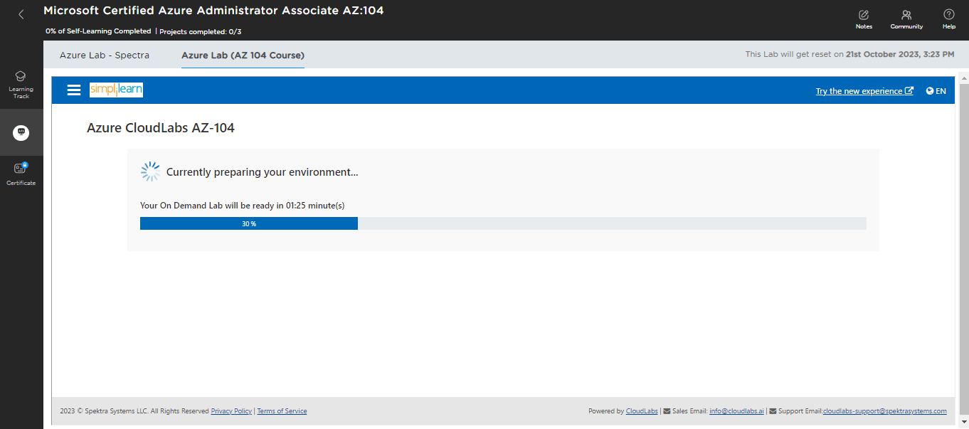

- Click on Microsoft Azure

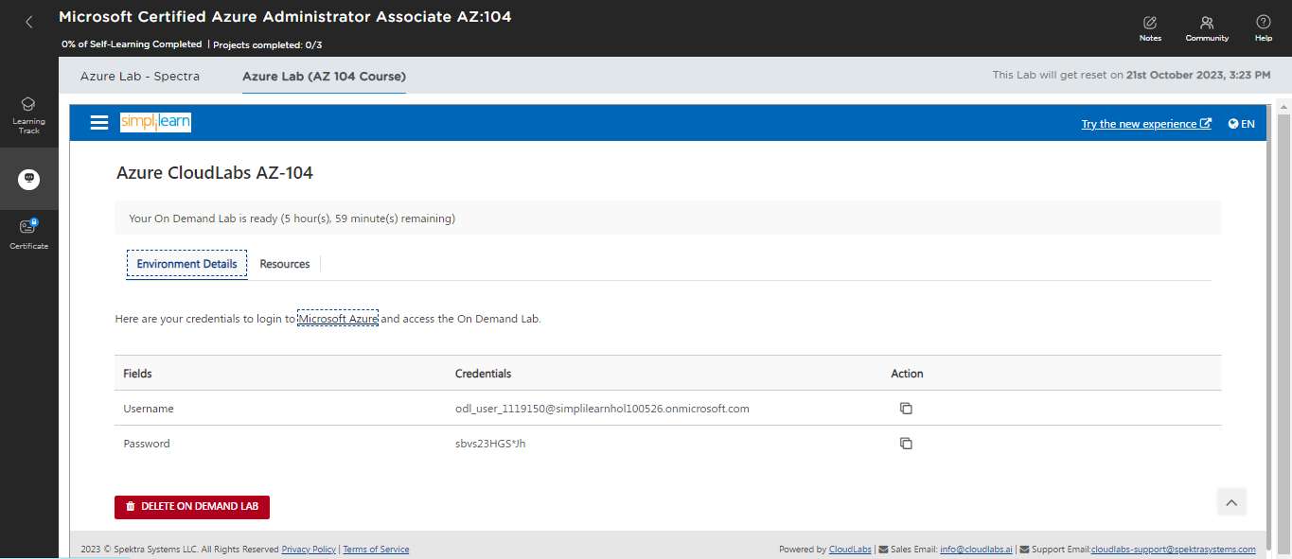

- Use the Credentials given to sign in

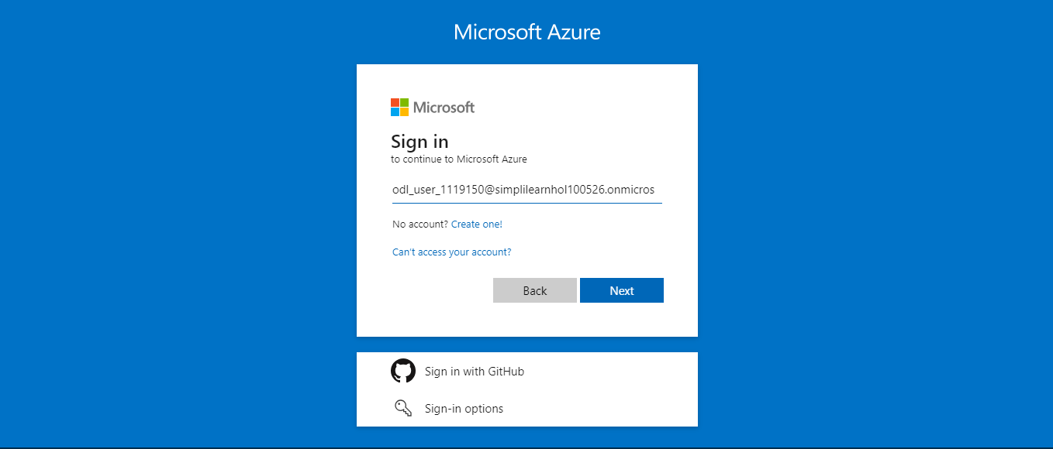

- Click on Ask later

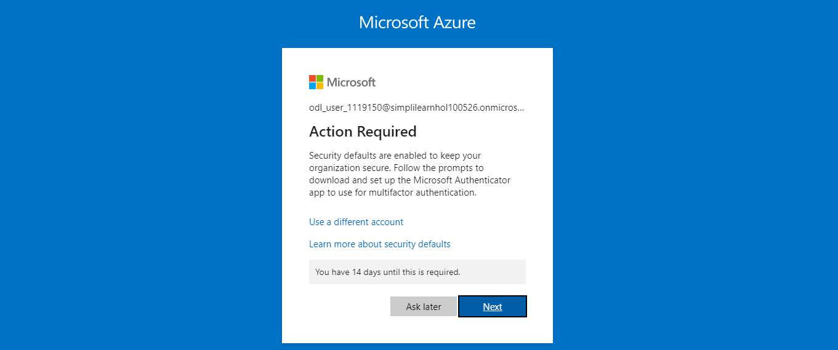

The Microsoft Azure lab will open as shown in the screenshot below:

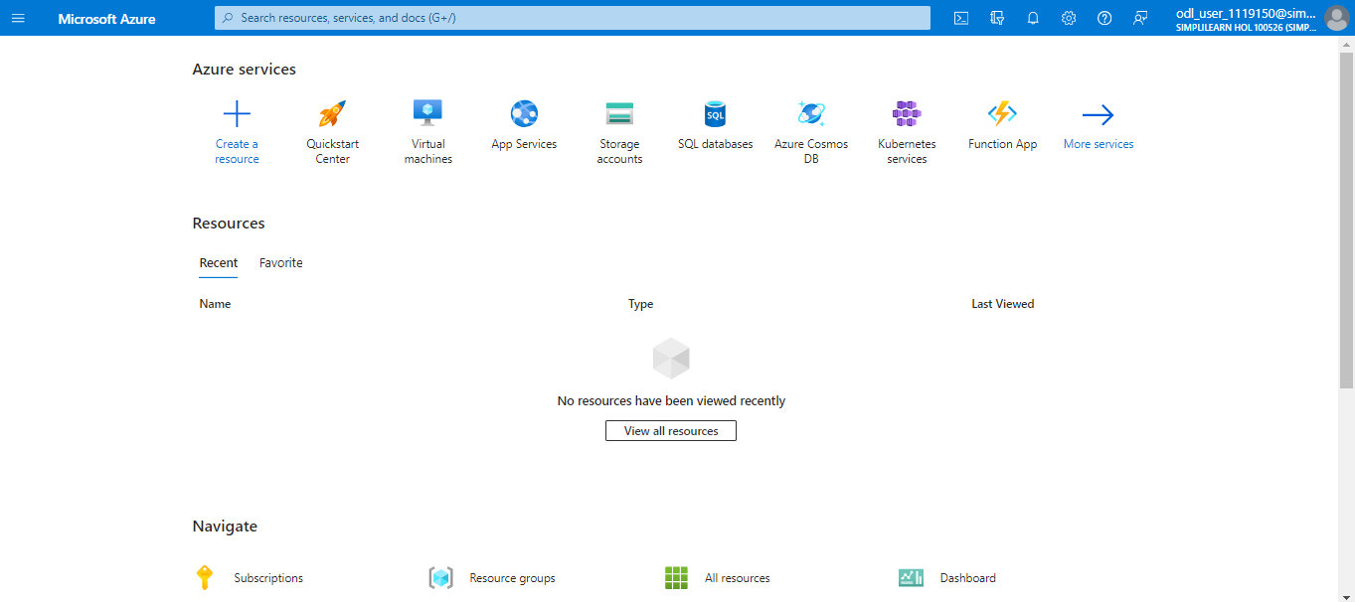

Step 2: Launch Cloud Shell from the Azure portal

- Click on the Cloud Shell option next to the search bar

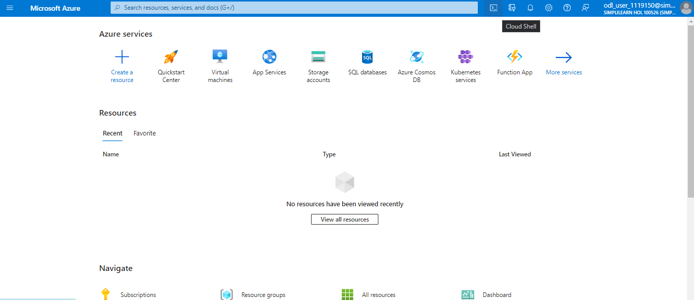

Step 3: Navigate to your choice of Azure Command Line

3.1 Select either Bash or PowerShell

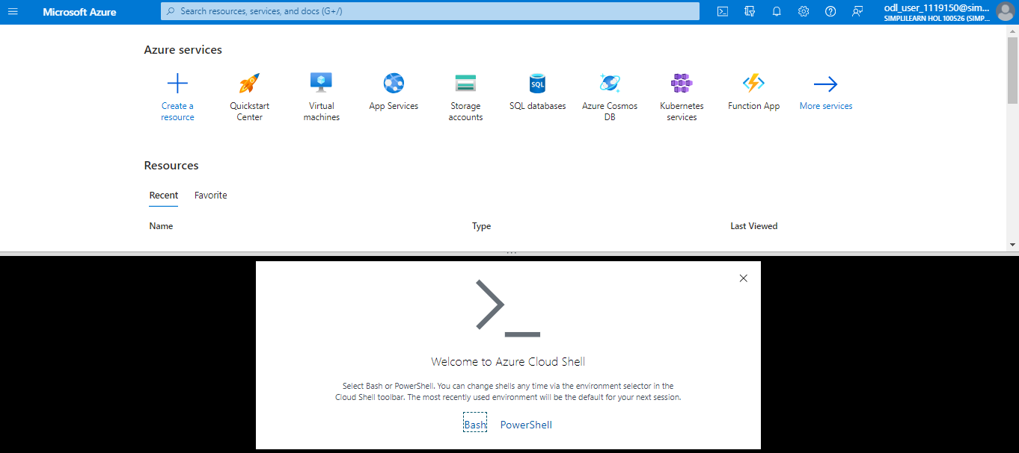

3.2 The first time you start Cloud Shell, you are prompted to create an Azure Storage account for the Azure file share. Select the Subscription used to create the storage account and file share and click on Create storage.

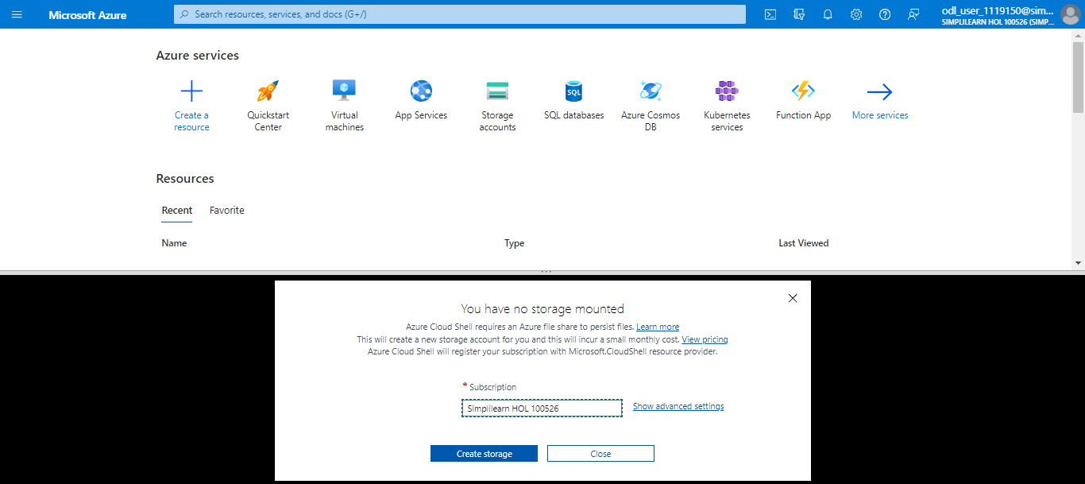

Step 4: Run commands based on the selected environment

4.1 Select either Bash or PowerShell for your command-line experience
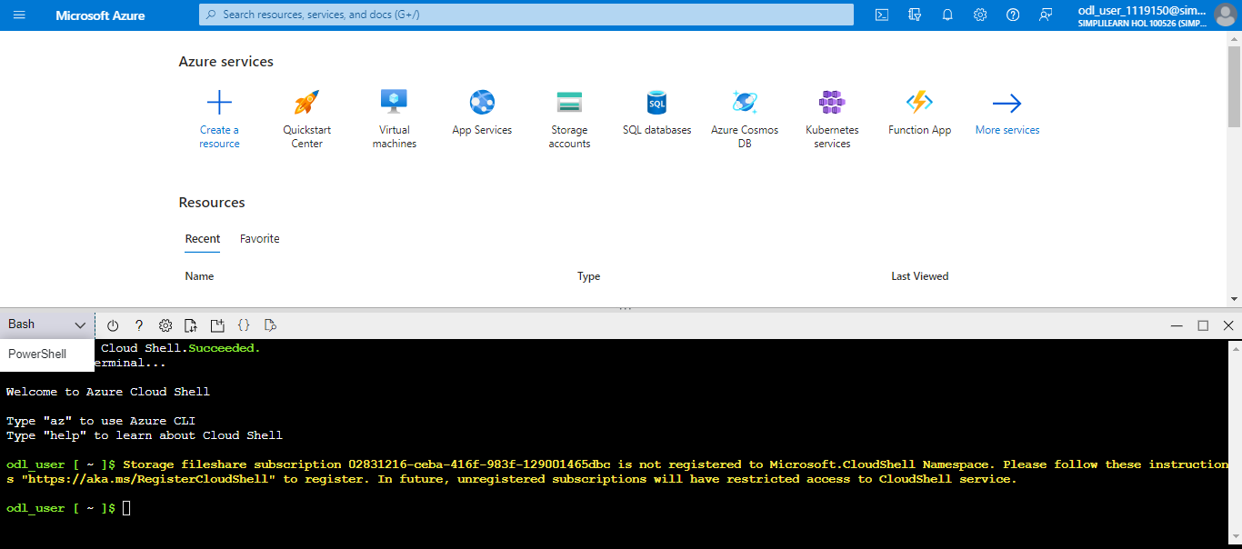

4.2 To get the subscription ID, go to the Subscriptions option

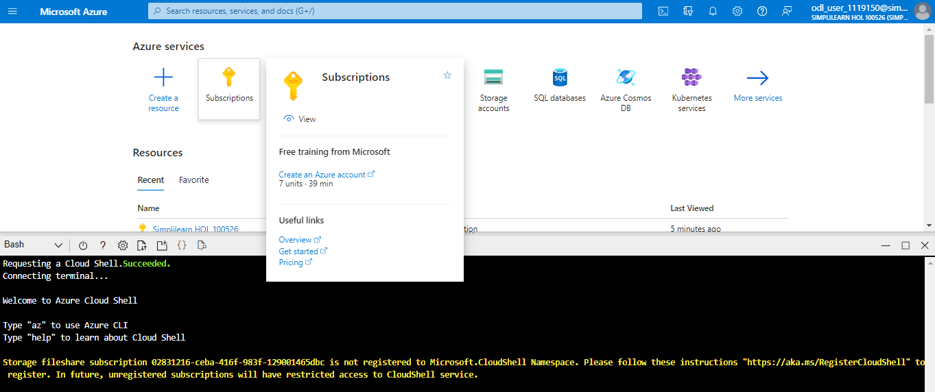

4.3 Copy the Subscription ID

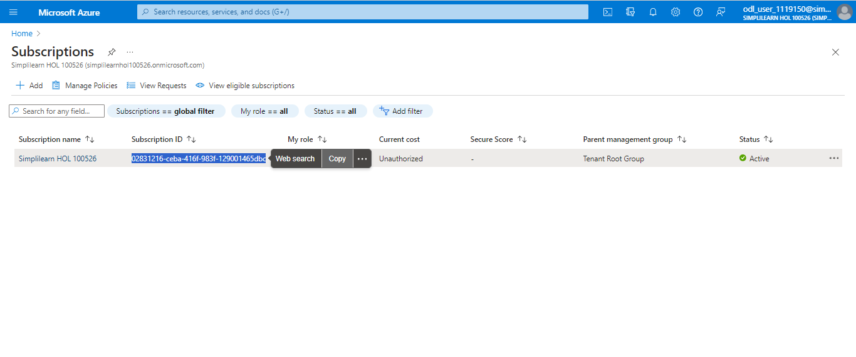

4.4 Azure Cloud Shell needs access to manage resources. Access is provided through namespaces that must be registered to your subscription. For Azure command-line interface (CLI), run the following commands to register Microsoft.CloudShell namespace under your subscription:

- az account set --subscription <Subscription Name or Id>
- az provider register --namespace Microsoft.CloudShell

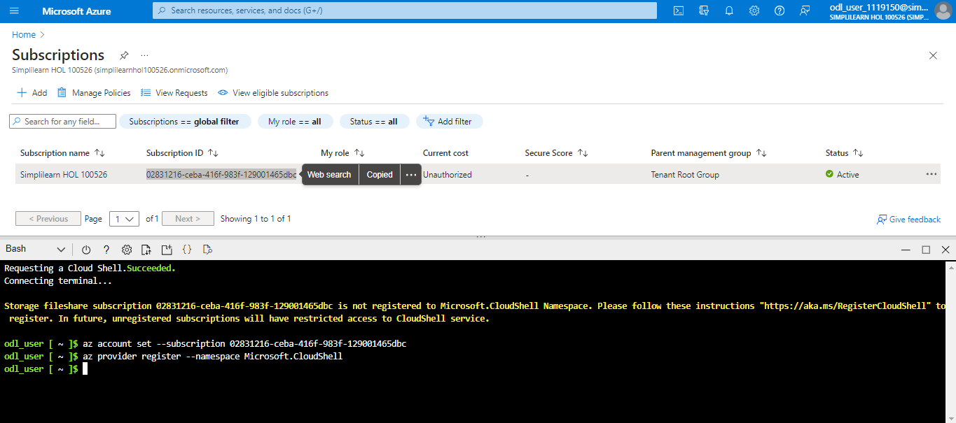

4.5 To use PowerShell, select the PowerShell

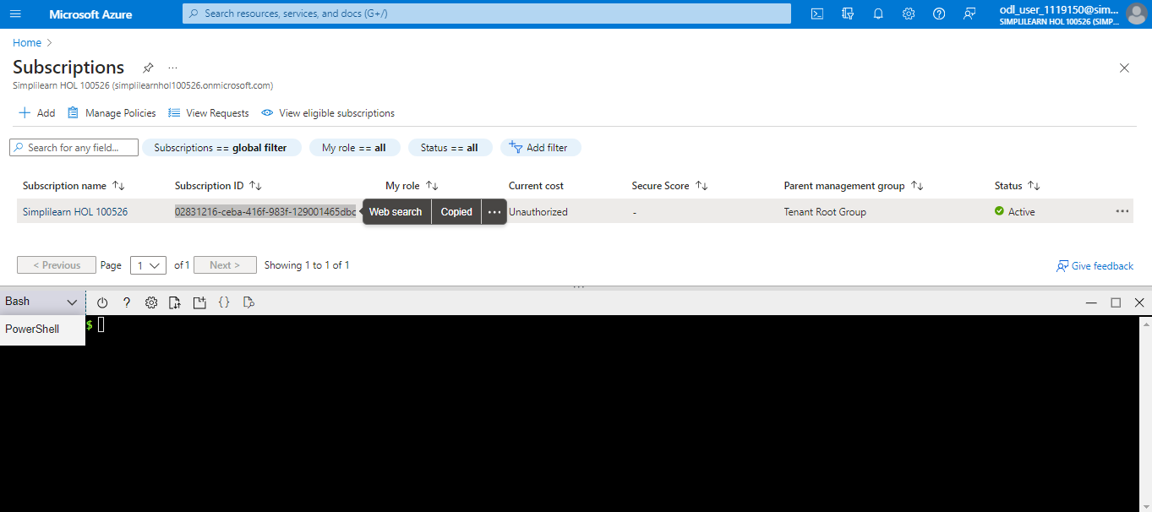

4.6 Click on Confirm

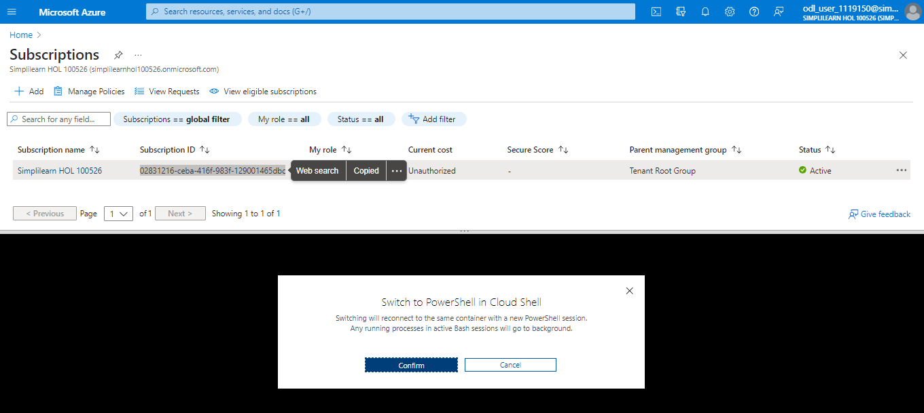

4.7 Register the namespace under your subscription

- First, run the following command:
Select-AzSubscription -SubscriptionId <SubscriptionId>

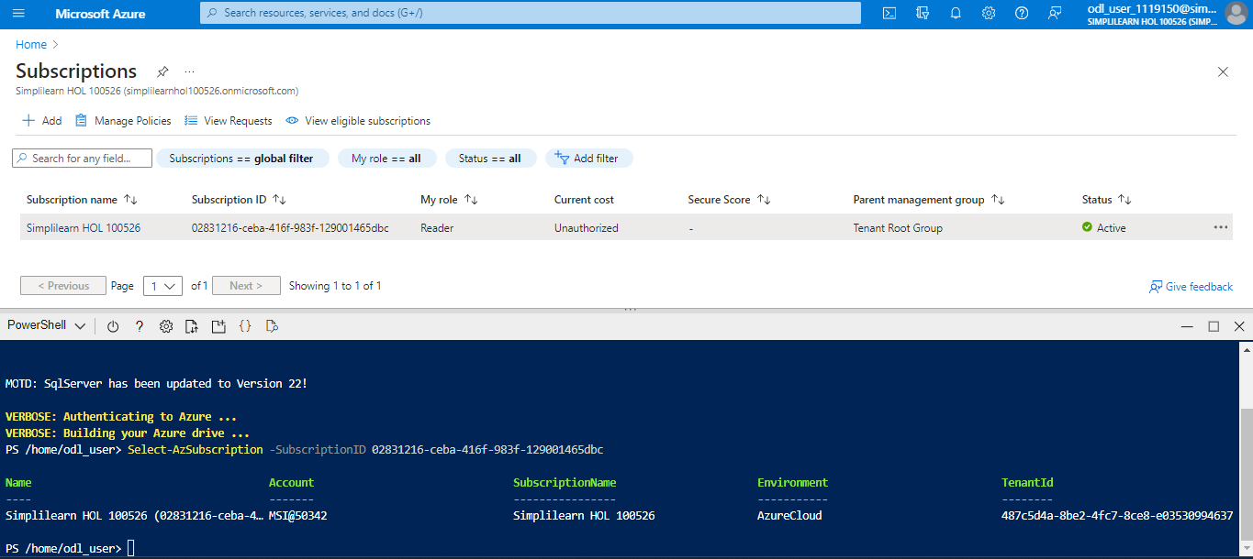

- Then, run the below command:
Register-AzResourceProvider -ProviderNamespace Microsoft.CloudShell

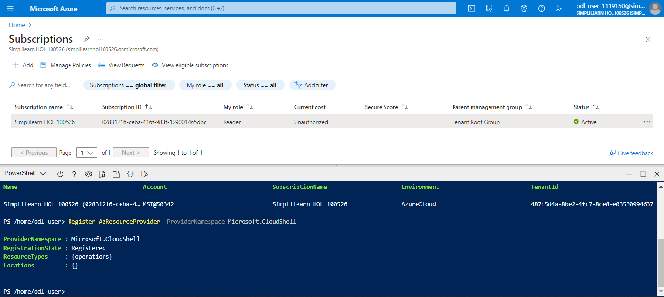

Note: You need to register the namespace only once per subscription.

This was a detailed walkthrough of Azure Cloud Shell.
Additional commands:

- Run the command az to see the list of all Azure CLI commands
- Run the command Get-Command-Module Az.* to see the list of all Azure PowerShell cmdlets
- Use the following commands to list subscriptions you have access to:
- For Azure CLI: az account list
- For Azure PowerShell: Get-AzSubscription
- Use the following commands to set your preferred subscription:

- For Azure CLI: az account set --subscription 'my-subscription-name'
- For Azure PowerShell: Set-AzContext -Subscription <SubscriptionId>

